Content for the News and Events page

Item 1.

Press Release

UNDP launches new insurance and risk finance facility

Image: (placed in hero images folder)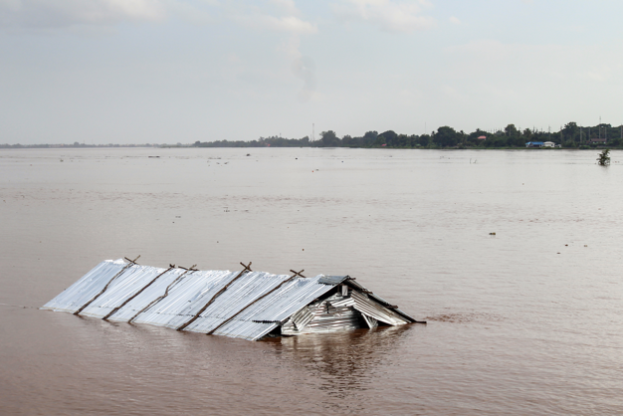
UNDP/Lao

UNDP launches new Insurance and Risk Finance Facility
The new Insurance and Risk Finance Facility (IRFF) aims to build financial resilience and bridge the $1.4 trillion global health, mortality, and disaster protection gap.
POSTED by UNDP new york on SEPTEMBER 27, 2021

New York, Sept 27 – The United Nations Development Programme (UNDP) today announced a new flagship initiative — the Insurance and Risk Finance Facility (IRFF), within its Finance Sector Hub. The Facility will strengthen the protection of vulnerable communities from socio-economic, climate and health-related disasters, by significantly increasing the role of insurance and risk-financing in development. The German Government has contributed €35 million in funding for the Facility to advance delivery of the InsuResilience Global Partnership's Vision 2025, which was presented at the UN Climate Action Summit 2019.

Economic losses from disasters cost 77 poorest countries an average of US$29 billion annually – with only 3% covered by insurance, forcing many to bear response and reconstruction expenses alone, or rely on aid. In 2020 alone, 980 disasters caused by natural hazards cost the global economy over US$210 billion. Following the COVID-19 crisis, 150 million people have been pushed back into poverty.
“In a world of growing and converging risks, developing countries and their communities are often the worst affected and the least able to rebuild and recover. Without financial resilience, the most vulnerable can be locked into a downward spiral of debt and poverty. Faced with these challenges, insurance and risk-finance products, tools and services can secure our critical infrastructure, protect our agriculture and businesses, and preserve critical ecosystems that make life on earth possible.” stated Achim Steiner, UNDP Administrator.
Insurance and risk financing provide a critical safety net, protecting assets, lives and livelihoods from the impact of crises. The IRFF will be present across five regions globally, working with the insurance industry and government to transform markets. The ambition is to co-create insurance and risk finance solutions in over 50 developing countries by 2025, embed them in public financial decision-making, and greatly contribute to the InsuResilience Vision 2025 target of protecting 500 million poor and vulnerable people by 2025.

"Building the financial resilience of countries and communities is a critical element of tackling climate change and safeguarding past and future development gains. Germany is strongly committed to the InsuResilience Global Partnership to enhance protection from climate impacts. Risk finance and insurance solutions enable the delivery of effective disaster response and help countries to be better prepared for the impacts of climate change and other shocks by reducing humanitarian impacts, building people’s capacity to recover more quickly and strengthening community resilience. In 2020 alone, more than 200 projects in over 100 countries contributed to the InsuResilience Global Partnership, protecting an additional 137 million people", says Dr. Maria Flachsbarth, Parliamentary State Secretary, German Federal Ministry for Economic Cooperation and Development (BMZ).
"The global community made a commitment at the UN Climate Summit in 2019, and all of us – governments, industry, the development sector – need to step up our work to enable climate-proof development.”
Under the IRFF, UNDP will be driving the country level change by working with governments to include climate risk modelling work in National Development Plans and Financing Strategies, Nationally Determined Contributions, National Adaptation plans and more.
“The insurance industry recognizes that the new challenges we collectively face – the climate crisis being the largest of them all – require public-private solutions. We welcome the investment UNDP is making through the launch of its Insurance and Risk Financing Facility to work together with the insurance industry at this crucial juncture. This demonstrates the progress the insurance and development community are making and will allow us to ramp up results on the ground. ” says Denis Duverne, Chairman of Axa and Chairman of the Insurance Development Forum.

The work of UNDP’s IRFF is built on partnership. A critical example is the Tripartite Agreement which was signed during the United Nations Secretary General’s Climate Action Summit in 2019, between the Insurance Development Forum, a (public-private partnership between industry and the multilateral sector to address development challenges) the German Government (BMZ) and UNDP. The partnership includes significant technical assistance and financial commitments from ten of the largest insurance companies in the world (Allianz, AXA, Axis, Guy Carpenter, Hannover Re, Munich Re, SCOR, Swiss Re, Willis Towers Watson and Aon), working with UNDP to build long-term financial resilience in countries.

About the Insurance and Risk Finance Facility (IRFF)

For Media Queries:
UNDP New York- Sangita Khadka, Communications Specialist,email: sangita.khadka@undp.org
UNDP Geneva- Sarah Bel, Communications Specialist, email: sarah.bel@undp.org

Item 2.

Speech

UNDP Administrator Achim Steiner’s keynote at IDF COP26 event

Image: (in hero images folder)

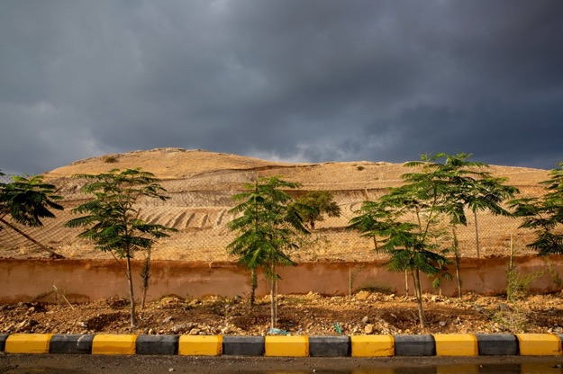
UNDP/Sumaya Agha

Speech delivered by UNDP Administrator, Achim Steiner the “Building Resilience in a Riskier World: Action towards a climate resilient future” IDF COP26 event held Wednesday 3rd November 2021

Excellencies, Ladies and Gentlemen,

The world today is tackling crises on multiple fronts: from the ongoing COVID-19 pandemic to the ongoing destruction & degradation of our natural world, to a rapidly changing climate.

The fragilities of our societies, economies, and healthcare systems, have all been laid bare.

We cannot simply return to the world we had before.

Every entity, individual, government and business has “skin in the game” when it comes to building forward better.

The Uncomfortable Truth About Climate Change

To do this, there are some uncomfortable truths that we must address head-on as COP26 convenes.

Last year, nearly 1,000 disasters cost the global economy over $210 billion.

Or look to India where disasters cost some $87 billion.

These are massive figures.

Over 60% of this cost was not protected.

In particular, insurance coverage for developing countries has been less than 10% of disaster losses in the past 20 years (OECD, 2021).

At present, there is a massive gap in financial protection which is limiting countries’ ability to recover and rebuild after disasters.

At the same time, the world is struggling to limit the global temperature rise to 1.5 degree Celsius.

Therefore, there will be future risks that will need insurance protection. We must develop the systems and tools now that will build future resilience.

The Good News

Now the good news.

Developing and scaling affordable insurance and risk financing solutions for climate-related shocks and disasters is very much possible.

Doing so will reduce the fiscal load of vulnerable countries. And better financial management of crises and shocks helps to ensure economic, political, and social stability.

On today’s agenda, we are seeing some of the major shifts we need to make progress.
That includes the announcement of a formal partnership between the Insurance Development Forum and the V20 Ministers of Finance to establish the IDF’s Global Risk Modelling Alliance, This is an action-orientated partnership to promote access to risk and resilience analytics that will help to design targeted insurance solutions to some of the world’s poorest & most vulnerable communities.
Or consider the launch of the Global Resilience Index Initiative. It will support countries to make the investments they need in their insurance sector.

And critically, both initiatives will extend crucial longstanding industry expertise right to the doorsteps of those who make decisions in government.

UNDP’s Added-Value

Excellencies, Ladies and Gentlemen,

Please allow me to highlight the contribution of the United Nations Development Programme and its recently launched Insurance and Risk Finance Facility.

Currently active in 20 countries, the Facility is working with industry and governments to develop much-needed insurance and risk-finance solutions across the globe.
That covers a wide range of areas including regulation, public assets, and agriculture.

In the coming months, we will be starting off new work in India, Uzbekistan, Ghana, Indonesia, Algeria, and Colombia.

In the coming four years, our target is to reach a minimum of 50 countries.

Central to much of what we do is the Tripartite Agreement, a partnership between UNDP, Germany’s BMZ, the Insurance Development Forum, and ten of the world’s largest insurance companies who have committed $5 billion in risk capital.

This collaboration between the industry, government and development agency is unlike any other. This is not merely a buzzword like “corporate social responsibility” – this is significant co-investment with developing countries.

However, even this significant partnership is not enough. As climate change intensifies, we must do much more to close the protection gap.

We are seeing how “one half” of the world is stuttering through recovery from COVID-19. These are parts of the world where vulnerable communities are bearing the brunt of our changing climate.

This much is clear: building forward better is the only way that we can achieve the Sustainable Development Goals.

Closing

Excellencies, Ladies and Gentlemen,

Climate change is the no.1 long-term risk out there. And we have the knowledge, expertise, and technology to mitigate the risk through innovation, knowledge-sharing, risk-taking, and market transformation.

So, wherever you may be across the globe – please count on the United Nations and UNDP as your close partner.

Finally, I would like to express my personal gratitude to all of you for your efforts to deploy insurance and risk finance at this pivotal moment.

You are “re-writing the rules of the game” -- ensuring a more level-playing field and helping to improve the lives of millions of people across the globe.

Thank you.

END

Item 3.

New Report

Tracking uptake of inclusive insurance products and services

Image: on google drive here
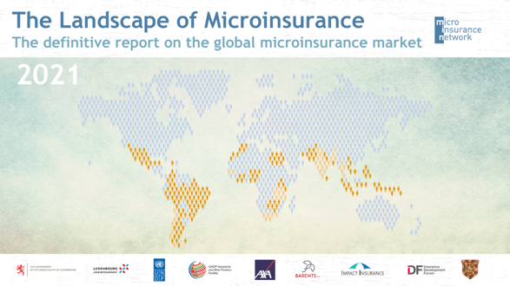

The Landscape of Microinsurance 2021 tracks the uptake of inclusive insurance products and services, along with insights into emerging trends. In this 2021 study, a total of 224 insurance providers were covered in 30 countries in Africa, Asia and Latin America and the Caribbean. Findings are based on extensive primary research, and the information and data included in the report cannot be found anywhere else.
Five key findings:

- Between 179 and 377 million people were recorded as covered by a microinsurance product in the 30 countries covered by the Landscape of Microinsurance 2021. This is estimated to represent between 6% and 14% of the target population of the countries studied. These figures represent a considerable increase on the previous year’s study, in which between 162 and 253 million people were reached across 28 countries, representing between 6% and 10% of the target population.

- Health microinsurance became the largest product line in Africa and Asia, reaching 104 million people globally (was life and credit life insurance in previous years), pushed by COVID-19.

- $1.13 billion premiums were collected in 2020, an increase of 6.5% from 2019.

- The potential value of the microinsurance market in the countries included in this study is estimated at USD 19.4 billion. In these countries, current microinsurance premiums represent about 6% of that potential market, based on data collected for this Landscape Study.

- The insurance industry is seeing a 18% yearly growth, since 1970.

To read the study, click here.

UNDP supports the Microinsurance Network in producing a series of landscape studies.. The partnership was announced on October 25, during the International Conference on Inclusive Insurance by Jan Kellet, lead of UNDP’s Insurance and Risk Finance Facility. Learn about IRFF’s inclusive Insurance work here.

Item 4.

Article

Can local insurers invigorate Africa’s green infrastructure?

Image : placed in heros folder on gdrive

Insurers have an opportunity to underwrite much-needed private-sector climate resilient and low carbon infrastructure projects in Africa and can even fund such green ventures themselves. How is the market developing? And is there room for African players?

UNDP Insurance and Risk Finance Facility’s Lauren Carter and Linet Odera contribute to this article about how the IRFF is working to build capacity of local African players, so they can underwrite and potentially invest in the continent’s sustainable infrastructure needs.

Read the full article: https://www.theafricaceoforum.com/en/ressources/can-local-insurers-invigorate-africas-green-infrastructure/

This article appeared in Jeune Afrique on August 31st 2021.

Item 5. Forthcoming

Short-Blog

Insurance and risk financing solutions to protect biodiversity and ecosystems

Item 6. Forthcoming

Blog

Climate Change is now the World’s No.1 Risk -- Here’s A Way Forward

